**Leader Overview**

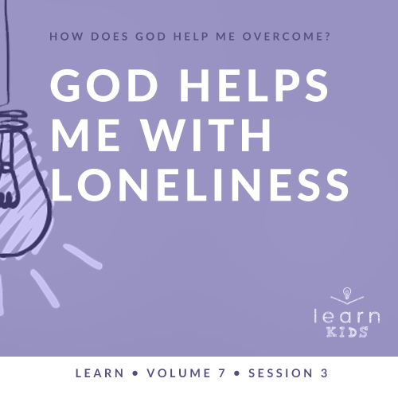

**Volume Overview**

**How does God help me overcome?**

*Life can be full of challenges. Thankfully, when we make the decision to live for God, we can have confidence that we’re no longer walking through life alone. God offers His help to us throughout every difficult circumstance. He knows that we’ll face fears, decisions, and emotions that we don’t feel equipped to handle. When we don’t know what to do, we can turn to God for the answer. He will help us overcome every challenge.*

**Session Overview**

**God Helps Me with Loneliness**

*Everyone feels alone at different times in their life. As Christians, when we feel lonely, it’s important we know that God is with us. We can (and should) talk to Him about all our feelings. In our Bible story, Joseph may have felt more alone in prison than we can possibly imagine, but God sustained him through that season. God even used Joseph in this lonely time to help those around him.*

**Bible Lesson**

Joseph in Prison

[Genesis 40:1–23](https://ref.ly/logosref/Bible.Ge40.1-23)

**Faith Fact**

God helps me when I feel alone.

**Faith Verse**

[Philippians 4:13](https://ref.ly/logosref/Bible.Php4.13) (NLT)

For I can do everything through Christ, who gives me strength.

**Preparing for the Session**

**Leader Preparation Time: 20–25 Minutes**

|  |
| --- |
| ***You Will Need***  ***Large Group***   * *Bible* * *Worship songs (Song suggestions: “Nothing Is Impossible” by Planetshakers; “Won’t Let Go” by Gateway Kids Worship; “Overcome” by Elevation Worship; “Holy Ground” by Passion)* * *For groups not using a phone or tablet only, add:*   *• Projector or TV*  *• Laptop*  *•* ***Faith Fact Slide***  *•* ***Faith Verse Video*** *or* ***Slide***  *•* ***Bible Lesson Video***  *•* ***Large Group Game Slide***  *•* ***Teaching Point Slides 1–3***  *•* ***Large Group Game Page****, one per every ten kids*  ***Small Group***   * *Small button, coin, or another small object, one per group* * *Bibles for kids in your group to share* * ***Small Group Faith Verse Review****, one per team* * *Scissors* * *Cups, one per team* * *Smartphone with timer* * ***Small Group Activity Page****, one per kid* * *Crayons, markers, or colored pencils*   *To access session content and videos from a computer, visit:* [*BibleEngagementProject.com/downloads*](https://bibleengagementproject.com/downloads) |
| ***Getting Ready***  ***Large Group***   * *Download videos and slides if needed.* * *Select worship song(s) and have them ready to play.* * *Read the Bible Lesson Scripture to prepare for Teaching Time.* * *Print the* ***Large Group Game Page****, one per every ten kids.*   ***Small Group***   * *Print and cut apart the* ***Small Group Faith Verse Review****, one set per team.* * *Place each set of slips in a cup, one set per team.* * *Print copies of the* ***Small Group Activity Page****, one per kid.*   *First time leading* Learn *for Kids? Check out the* [*Facilitator Guide*](https://0b769b0ed3569ef9d18b-f88d8272f61086866d50d048b43ef630.ssl.cf2.rackcdn.com/sites/biblengagementproject/Listen_Facilitator_Guide.pdf)*.* |

**Large Group**

**30 Minutes**

*See what’s needed at the beginning of the session.*

**Introduction**

Hello everyone! I’m so excited that you’re here. Today, we’ll learn that God helps us with loneliness. There are many times in life when we feel alone. Has anyone ever been lost somewhere? *(Allow responses.)* It can be pretty scary sometimes.

• *Insert a personal story about a time that you were lost. Try to keep it light and something kids can relate to if possible.*

• *If you can’t think of a personal story, talk about what it would be like to get lost from your parent at the grocery store because you stopped to look at the candy and didn’t know that your parent has moved on with shopping.*

**Faith Fact**

Everyone feels lonely at some time or another. God helps us when we feel that way because He is with us all the time. Our Faith Fact today is a great reminder of that. **God helps me when I feel alone.**

• *Show the* ***Faith Fact Slide.***



This is something important for you to remember today. As a reminder that you’re never completely alone, move next to someone near you. Make sure no one is alone.

• *Pause while kids pair up.*

Now, say the Faith Fact together. **God helps me when I feel alone.** Let’s say it one more time extra loud. **God helps me when I feel alone.** Great job! Go ahead and find your seat.

**Game**

**Barnyard Match**

|  |
| --- |
| ***You Will Need***   * ***Large Group Game Page****, one per every ten kids* * ***Large Group Game Slide*** * *Scissors* * *Paper sack or small gift bag*   ***Getting Ready***   * *Print the* ***Large Group Game Page****, one page per every ten kids.* * *Cut apart the animal slips, fold in half, and place in the bag.* |

Raise your hand if you live on a farm or you’ve ever been to one. *(Group response)* Today, we’re going to play a game called Barnyard Match.

• *Show the* ***Large Group Game Slide.***



Normally, a farmer doesn’t have just one cow or one pig. They have many of them, so the animals aren’t alone.

In this game, each one of you will be a farm animal that has run away from the farm. As quickly as possible, you’ll work together to find the other animals like you. Just like on the farm, the animals make sounds to “talk” to each other. Let’s practice the animal sounds you’ll need to know.

• *Share the sounds for the animals in the game. Then, have kids repeat after you.*

• *Cow: “Moo”*

• *Pig: “Oink”*

• *Horse: “Neigh”*

• *Sheep: “Baa”*

• *Rooster: “Cock-a-doodle-doo”*

Now that we know what each animal sounds like, it’s time to find out which animal you’ll be. After you draw an animal picture out of the bag, peek at it carefully so no one can see which animal you are. Then, fold it up and hold it in your hand.

• *Let everyone draw a slip from the bag.*

When I say, “Go!” you need to find the other animals like you in the room, but you can only use the sounds your animal makes. Don’t show the picture or say the name of the animal. The first team to gather as the same animal and sit down in a circle wins. Finally, you’ll open up your papers to show that your pictures match.

Before we start, everyone spread out around the room to pick a random starting spot. Don’t give away what animal you are.

• *Pause while kids find a spot.*

Now find the animals like you. Go!

• *Give kids time to find their group.*

Great job, everyone! That was a crazy barnyard just now, but I’m glad you were able to find your matches. It’s better to be together instead of being a lone cow or sheep. You might not have felt lonely when you started the game because you found a group to belong to.

Sometimes in life we can be alone for much longer. That’s when we might start to feel lonely. We need to remember that God is always with us whether we realize He is or not. That’s a good time to remember the Faith Fact. Let’s say it now. **God helps me when I feel alone.**

**Worship**

I’m so thankful that God never lets us be completely alone, aren’t you? *(Group response)* One way we can become more aware of God’s closeness is through worship. Who’s ready to worship God today? *(Group response)* One way we worship God is by singing. Let’s worship Him together.

• *Lead the kids in singing one or two praise songs. See suggestions at the beginning of the session.*

**Bible Lesson**

That was an incredible time of worshipping God together! Now, it’s time to learn from God’s Word. Today, we’ll learn more about a man named Joseph. He’s already faced some pretty hard things.

What has happened to Joseph so far? *(Allow responses.)* First, his brothers got mad at him and he ended up far from home in Egypt. Then, Potiphar got mad at him and had him thrown in jail. Now, he’s in prison, far away from his family. Joseph didn’t deserve to be sent to prison, but he stayed faithful to God, and God was with Joseph. Even if Joseph felt alone, he never really was. Today’s Bible story teaches us about who God is and how He can be near to us all the time.

**Prayer**

|  |
| --- |
| *Dear God, thank You for Your Word and that it can show us how close You are to us every day. Help us to learn more about how we’re never alone if we know You. Amen.* |

**Video Intro**

Just before we look at the Bible story, let’s watch this video.

• *Play* ***Bible Lesson Video****.*

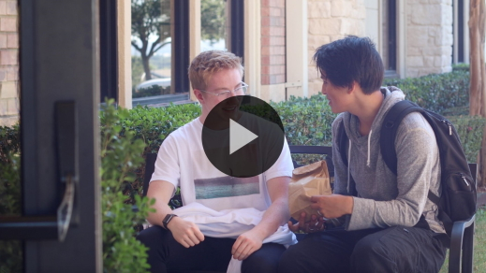

**Bible Story**

**Joseph in Prison**

That video was such a fun lead-in to our Bible story today! We talked about getting lost earlier. At some point or another, I think we all have felt lost. When we realize we’re lost, what kinds of things might we feel? *(Allow responses.)* Those are good answers.

We all feel a little lonely every now and then, too. Thankfully, God’s Word gives us some tools to use so that we can be aware of God’s closeness to us. The Bible shows us how to handle loneliness when it comes. Grab your Bible or pull up a Bible app on your device. Turn to [Genesis 40:1–23](https://ref.ly/logosref/Bible.Ge40.1-23).

• *Read the Bible story aloud to the group.*

• *In order to keep Large Group time moving along, we don’t recommend having the kids read.*

• *Optional: Remind the kids to mark this place with their Bible Bookmark, so they can read it on their own at home.*

**Teaching Time**

|  |
| --- |
| ***You Will Need***   * ***Teaching Point Slides 1–3***   *No prep needed for this activity.* |

Can you imagine being Joseph in this situation? Joseph was far from his home and family in prison, but God still used him to do powerful things to help others. God used Joseph to interpret other people’s dreams. Joseph may have felt alone, but God showed He was close to Joseph by using him in this hard situation. We can learn a lot from Joseph about what we should do when we feel alone. That’s why our Faith Fact is so important. Say it with me. **God helps me when I feel alone**.

Here are three things you need to know whenever you feel alone.

**1. When I feel alone, I know God is with me.**

• *Show the* ***Teaching Point 1 Slide.***

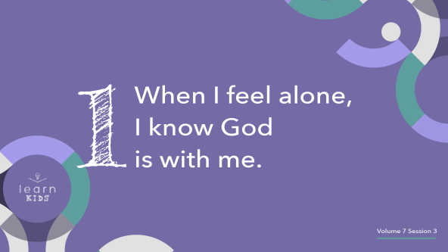

Everyone is going to feel alone at one time or another. We might feel alone at recess if we don’t have anyone to play with. We might feel alone if we go somewhere and don’t know anyone. We can even feel lonely when we’re surrounded by people because we don’t feel connected to them. You could feel alone right now even though we’re all here together. Feeling lonely can be challenging to work through.

First, remember that God is always with you even when you feel like He isn’t. Sometimes, we don’t realize that something is close to us even though it really is. Here’s a good example. There is something very close to you. It’s right in front of your eyes. It’s been there this whole time, but you probably didn’t even notice. Anyone know what it is? *(Allow responses.)* It’s your nose.

Look down at your nose. Raise your hand if you can see it. *(Group response)* If you can’t see it, make sure it’s still there by touching it. *(Group response)* When you aren’t looking for your nose or when you’re more focused on something else, it’s almost like we don’t even notice our nose is there. When we look for our nose, it’s pretty easy to find. The same thing can happen when we feel alone. It can be hard to notice where God is. When we think about Him, we may notice that He has been with us the whole time.

It might not always be easy to notice where God is when we look for Him though. If that ever happens, try remembering other times when God has been with you. Pray and ask Him to encourage you and to help you see how close He is to your situation.

**2. When I feel alone, I can talk to God.**

• *Show the* ***Teaching Point 2 Slide.***

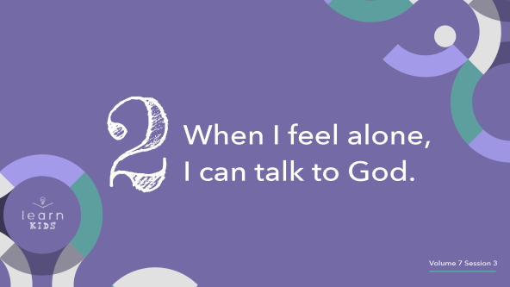

Do you ever feel lonely when you go somewhere new? *(Group response)* Imagine going someplace for the first time like karate lessons, a new school, or a new church. When you first go there, it can feel really uncomfortable, especially if you don’t know anyone. You can end up feeling alone. The more you’re at that place, the more you’ll meet people and make friends. When you have someone to talk to, it makes it so much easier to not feel alone.

Now, imagine going to one of those places for the first time with your best friend. Would you feel lonely then? *(Group response)* It would be so much easier to not feel alone because you have someone with you to talk to.

When we go to a new place, our friends or family won’t always be with us, but God will. We can talk to Him at any time. Although it might seem hard because God doesn’t always talk back to us the same way our friends do, we know that He hears us. He is here with us to help us, encourage us, and comfort us when we feel alone.

God wants us to talk to Him. Just like friends who talk about their feelings and share their struggles, God wants us to bring those things to Him. When we do that through prayer, He helps us have peace in our heart and mind even if we feel alone.

**3. When I feel alone, I can still help others.**

• *Show the* ***Teaching Point 3 Slide.***

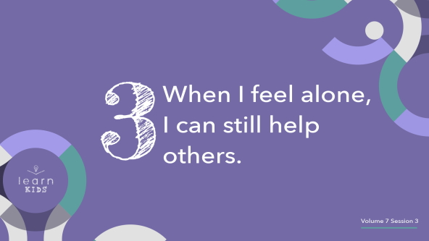

When Joseph was in prison, he probably felt alone at times, but he didn’t let that stop him from doing what he could to help others. The baker and cupbearer had crazy dreams that God helped Joseph interpret, and Joseph had to choose to help those men. I don’t know if Joseph felt like he wanted to help them, but he did. This is an example that we can follow.

Imagine that you’re having a rough day and feeling lonely. While you’re on the playground, you see someone fall and hit the ground pretty hard. Does being lonely mean that you can’t help them? Of course not! You can definitely go over and help them. It doesn’t matter whether you’re happy, sad, angry, or lonely. The truth is God has given every one of us special gifts and talents that we can use to help other people and to show them His love. What’s even cooler is that when we help others, we might make new friends who can help us not feel as lonely.

It’s totally normal to feel lonely, but God wants us to know that He is with us when we do. We can talk to Him, and we can still help other people despite our loneliness. God helps us when we feel alone.

**Prayer and Response**

*Consider playing a worship song softly in the background while kids pray.*

Let’s pray together and ask God to help us remember that He’s close, that we can talk to Him, and that we can help others even when we feel alone. Maybe you want to ask God for help in one of these areas.

• *Optional: If you have multiple leaders, ask kids to gather around a leader for each one of the following prayer needs.*

If so, raise your hand as I say each one. If you feel alone right now and want God to feel closer, raise your hand. *(Group response)* If you need help remembering that you can talk with Him when you’re lonely, raise your hand. *(Group response)*. If you want to ask God to help you to see others who need help, raise your hand. *(Group response)* Thanks for your honesty.

**Prayer**

• *Optional: Have the kids repeat phrases of the prayer after you*.

|  |
| --- |
| Dear God, please help me to see how close You are to me even when I feel alone. Help me to see how I can talk to You and share my feelings with You. Help me to see how I can help others even when I feel alone so that they can know Your love. Help me to remember You are always with me whenever I feel alone. Amen. |

**Faith Verse**

Our Faith Verse reminds us that Jesus gives us strength to do anything He wants us to do.

• *Play* ***Faith Verse Video****.*

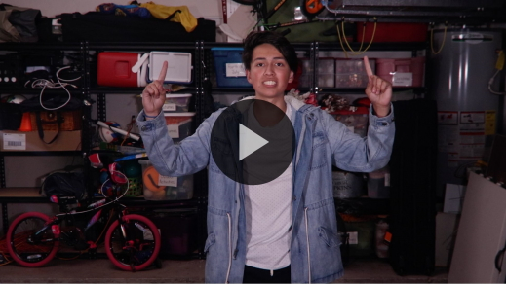

[Philippians 4:13](https://ref.ly/logosref/Bible.Php4.13) (NLT)

For I can do everything through Christ, who gives me strength.

Remember that anytime you’re alone, God will help you have the strength to know He’s close. God is always with us, helping us overcome life’s hard situations.

**Faith Fact**

Before we go to our small groups, let’s review our Faith Fact again.

• *Show the* ***Faith Fact Slide****.*



Say it with me. **God helps me when I feel alone.** Remember that God is always with you. He is always by your side, always listening to your prayers, and has a special work for you to do to help others around you.

• *Dismiss kids to Small Group time or to go home if your group time ends here.*

**Small Group**

**30 Minutes**

*This section can be done in conjunction with the large group or on its own if you do small groups with your kids. During Small Group time, the goal is to connect the kids with the Word of God and to each other. All activities are led by the small group leader.*

**Group Connection**

**Button, Button, Who’s Got the Button?**

|  |
| --- |
| ***You Will Need***   * *Small button, coin, or another small object, one per group*   *No prep needed for this activity.* |

All right, everyone! Let’s sit in a circle. I’ll choose one person to be “It,” and they will turn away from the group. The rest of the group will pass the button. As you’re passing the button from person to person, I’ll say, “Faith Fact.” That’s the cue for everyone in the group to clasp your hands together like you’re holding something. Then, we’ll say the Faith Fact as a group.

When the person who’s “It” hears us saying the Faith Fact, he or she will turn around and guess who has the button. Remember, everyone is trying to keep it a secret. Let’s play.

• *Choose someone to be It. Then, play the game.*

• *Let the person who has the button choose who gets to be It for the next round.*

Great job, everyone! How many of you thought that it was hard to tell who had the button? *(Group response)* The same thing can happen with loneliness. Sometimes it can be really hard to tell who in a room is feeling lonely. They might seem like everyone else. So don’t be afraid to share God’s love and kindness with everyone. You never know when God will use you to help someone not feel alone.

**Learn about It**

|  |
| --- |
| ***You Will Need***   * *Bibles for kids in your group to share*   *No prep needed for this activity.* |

**Scripture Search:** [**Psalm 139:7–12**](https://ref.ly/logosref/Bible.Ps139.7-12)**;** [**Isaiah 41:10**](https://ref.ly/logosref/Bible.Is41.10)**;** [**Romans 8:38–39**](https://ref.ly/logosref/Bible.Ro8.38-39)

Let’s dig deeper into God’s Word and see what else He has to say to us. As we find and read each of these verses, let’s consider: What does this Scripture mean for our life today?

• *Give each kid a Bible and search for one or more of the Scriptures as a group together (as time allows). When everyone has found the Scripture, have one of the kids read it. Then, answer the questions about it.*

• *Pair kids who need additional help with older kids or start simple and look up the session’s Bible story Scripture:* [*Genesis 40:1–23*](https://ref.ly/logosref/Bible.Ge40.1-23)*. Kids will get better at finding Scriptures the more they practice.*

• *Optional: Make this a competition to see who can find the Scripture first.*

**Bible Reading Tip**

God’s Word is so good. When you’re reading the Bible, it can help to have a blank piece of paper and a pencil or pen with you. As you read, you can write down special things that stick out to you or draw a picture of the story you read. Doing this helps us to remember God’s Word and to keep it in our heart.

**Challenge**

Here’s a challenge for you. This week, read a Bible story or some verses from our Scripture search. After you read it, write down or draw a picture of something that you thought was interesting. Then, hang whatever you wrote or drew where you can see it as a reminder of what you read.

Maybe you’ll find yourself in a situation where you feel alone this week. If you do, look at what you wrote or drew. Remembering what God spoke to you through the Bible can help you know God is always there and helping you.

**Faith Fact**

God’s Word is living and active. When we read God’s Word, we grow closer to God. We don’t have to feel alone, which reminds us of our Faith Fact. **God helps me when I feel alone.** Say it with me. **God helps me when I feel alone.**

**Group Discussion**

*Feel free to use all or just a few questions as a jumping-off place for good discussion. Questions marked with * are designed for more conversation. Adjust the questions based on the age or maturity of your group. Typically, older kids will be able to dive a little deeper than younger ones.*

**Questions**

• *If small group activities are not immediately following large group time, you may want to read the Bible story passage before this discussion.*

* Do you think Joseph felt alone in prison? Why or why not?

What two men were sent to the prison from Pharaoh’s house?

What were the meanings of the two dreams Joseph interpreted for the two men?

* What stuck out to you most about this Bible story?

When is a time that you might feel alone?

* How can you tell if someone else is feeling alone?

Why should you help someone else even if you feel alone?

* How would your life be different if you always remembered God is with you when you feel alone?

**Prayer Requests**

*Finish group discussion by sharing prayer requests and praise reports. Keep track of your small group’s prayer requests and review them each time you meet.*

**Prayer**

*Have kids pray for each other’s prayer requests.*

**Faith Verse Review**

|  |
| --- |
| ***You Will Need***   * ***Small Group Faith Verse Review****, one set per team* * *Scissors* * *Cups, one per team* * *Smartphone with timer*   ***Getting Ready***   * *Print and cut apart the* ***Small Group Faith Verse Review****, one set per team.* * *Place each set of slips in a cup, one set per team.* |

Our Faith Verse is [Philippians 4:13](https://ref.ly/logosref/Bible.Php4.13). This verse reminds us how we can have strength to make it through situations where we feel alone. Let’s review it now.

• *Show* ***Faith Verse Video****.*



[Philippians 4:13](https://ref.ly/logosref/Bible.Php4.13) (NLT)

For I can do everything through Christ, who gives me strength.

In the moment when you feel alone, remember that Jesus will give you strength to get through it. Let’s review our Faith Verse as a group. Try to memorize it as best as you can because you will need to know it for the Faith Verse game.

• *Say the verse as a group a couple times.*

**Faith Verse Fun**

**Verse Shuffle**

This verse is really encouraging when we’re lonely, so let’s challenge our memory. Let’s practice it by unscrambling it together. Pay attention because after we do it once together, we’ll divide into teams and see which team can finish first.

• *Give kids the* ***Small Group Faith Verse Review*** *slips.*

• *Practice the Faith Verse together and then divide into teams.*

• *Record the fastest times for the teams and declare a winner.*

Great job! This verse is a really good one to have in our mind and heart. It reminds us of God’s plan to help us with whatever we go through.

**Activity Page**

**Share Aware**

|  |
| --- |
| ***You Will Need***   * ***Small Group Activity Page****, one per kid* * *Crayons, markers, or colored pencils*   ***Getting Ready***   * *Print copies of the* ***Small Group Activity Page****, one per kid.* |

We can always talk with God even when we’re lonely. He wants to know how we feel.

• *Give each kid an* ***Small Group******Activity Page.***

Draw a picture or write about where you are or what you’re doing when you feel lonely.

• *Invite kids to tell you about their pictures.*

**Dismissal**

Remember that whenever you feel alone, God is with you. He is listening for your prayers, and He can be with you as you help others. God wants you to know that He is always with you every step of the way. Like Joseph, He can use you to help others even when you’re lonely. Let’s pray.

**Prayer**

|  |
| --- |
| *Dear God, thank You for helping us when we feel alone. Thank You for listening to us, guiding us, and always being there for us. We love You. Amen.* |

**Faith Fact Recap**

• *Show the* ***Faith Fact Slide****.*



I’m so glad that we got to learn from God’s Word together today! Something I want you to remember is our Faith Fact. Let’s say it together one more time. **God helps me when I feel alone.** I’m glad you came today. I can’t wait to see you next time**.**

• *Send home the* ***Small Group Activity Page.***

• *Remind parents that there are* ***Family Devotions*** *available on the app to do with their kid.*

• *Tell everyone the date and time for the next session*.